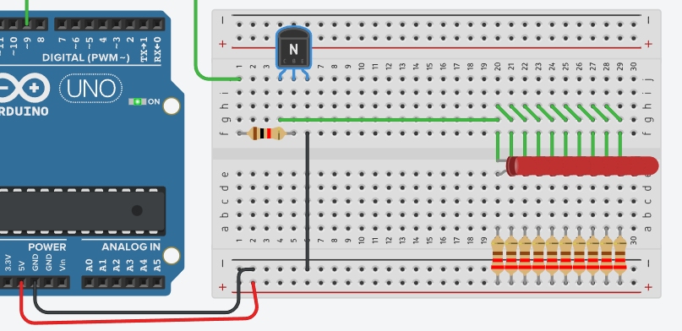

Биполярный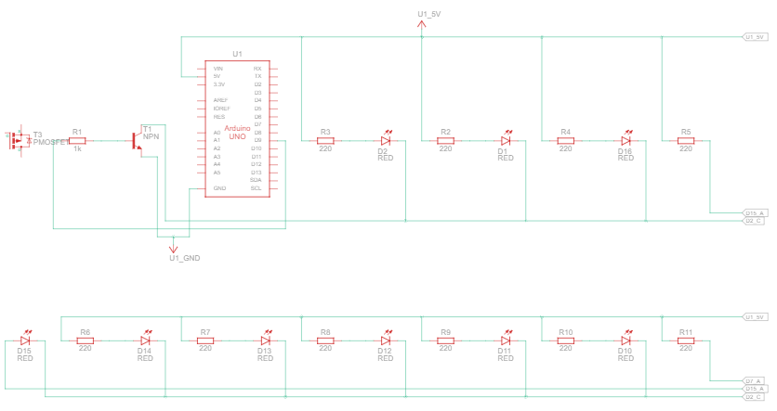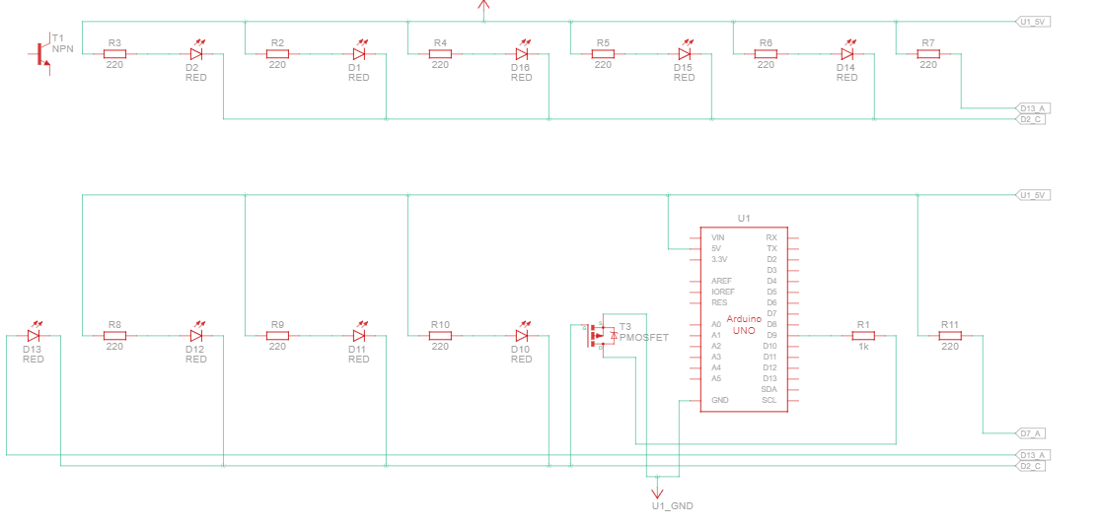Полевой

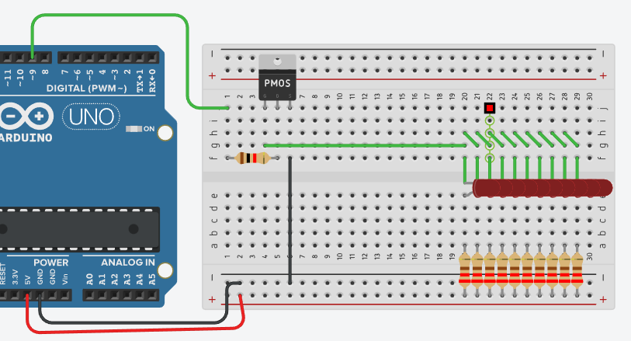

#define CONTROL_PIN 9

int brightness = 0;

void setup(){

pinMode(CONTROL_PIN, OUTPUT);}

void loop(){ brightness = (brightness + 1) % 256;

analogWrite(CONTROL_PIN, brightness);

delay(10);}